SAI DINESH MALLENI
Link for tableau file: https://utdallas.box.com/s/xagtlv1e1wv7g7by5ejgrshscws8w5ni
SECTION 1: Acquiring Data
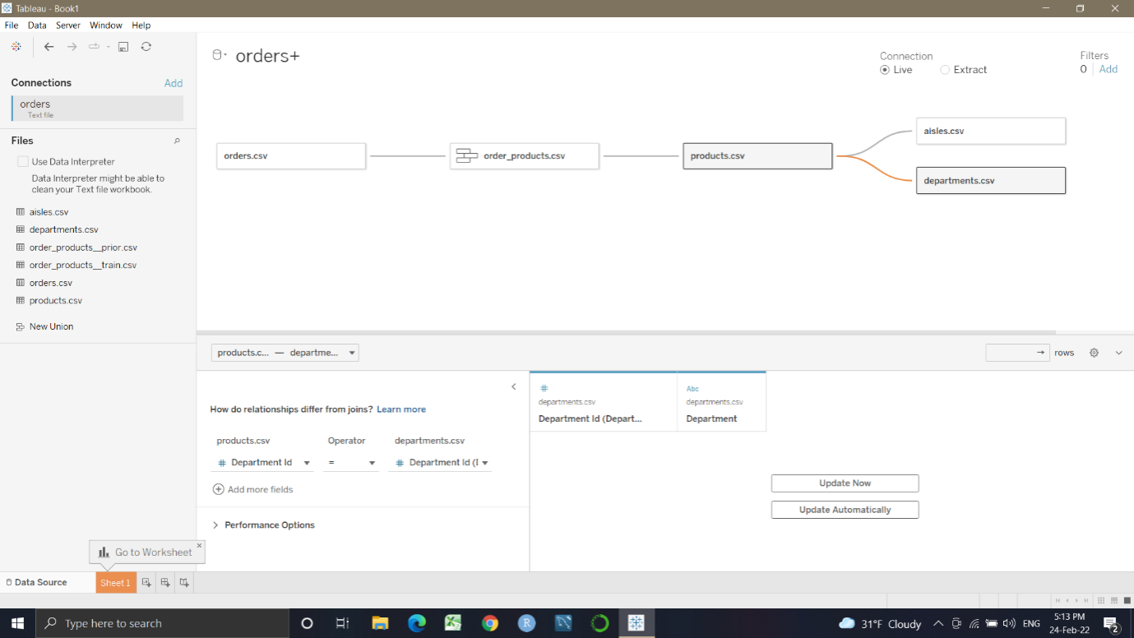

SECTION 2: Defining the audience
- What are the primary groups and individuals that are the focus of your communication?

- instacart President
- Instacart marketing executive
- Shoppers
- Partner stores (Albertsons, ALDI, CVS, Kroger, Loblaw etc.)
- Sales department
- Finance department
- Marketing department
- Procurement department

- List the executive role or position that is the key decision maker in your audience?
Looking at the data that we are analyzing, that is orders placed by various users, the sequence of products purchased in each order etc., the key decision maker would be the president of instacart.

- How much experience does your audience have working with this data? (Shallow or deep; include at least one defining sentence of justification)

Assuming the data is accessed by Instacart executives and various partner executives like Costco, Kroger, CVS, ALDIt etc., the experience of working with the data would be deep as there would be special data teams with experienced professionals working for them.

- What is the scope of your audience? (wide or narrow; include at least one defining sentence of justification)

The scope of our audience is wide as the data can be used by large set of people including instacart executives, partners, competitors etc.

- What does your audience care about? (you can circle back to this question after your analysis)

The audience ultimately care about augmenting the revenue of instacart so as to meet the interim goals in terms of sales, revenue and customer satisfaction.

- What action does your audience need to take? (you can circle back to this question after your analysis)
Advertising campaigns, promotional events, better environment for shopping in terms of sanitation, cleanliness, free and quick delivery for returning customers etc. so as to improve customer satisfaction and revenue.

- What are the stakes? (what matters, what is the point)

- People shopping with competitors, churning out customers
- Lost revenue
- Loss of reputation
- Losing existing partners

- What is the big idea? (this will form the main storyline)

To improve the revenue of instacart and shopping experience of customers by taking optimal decisions after analysing the data.

SECTION 3:
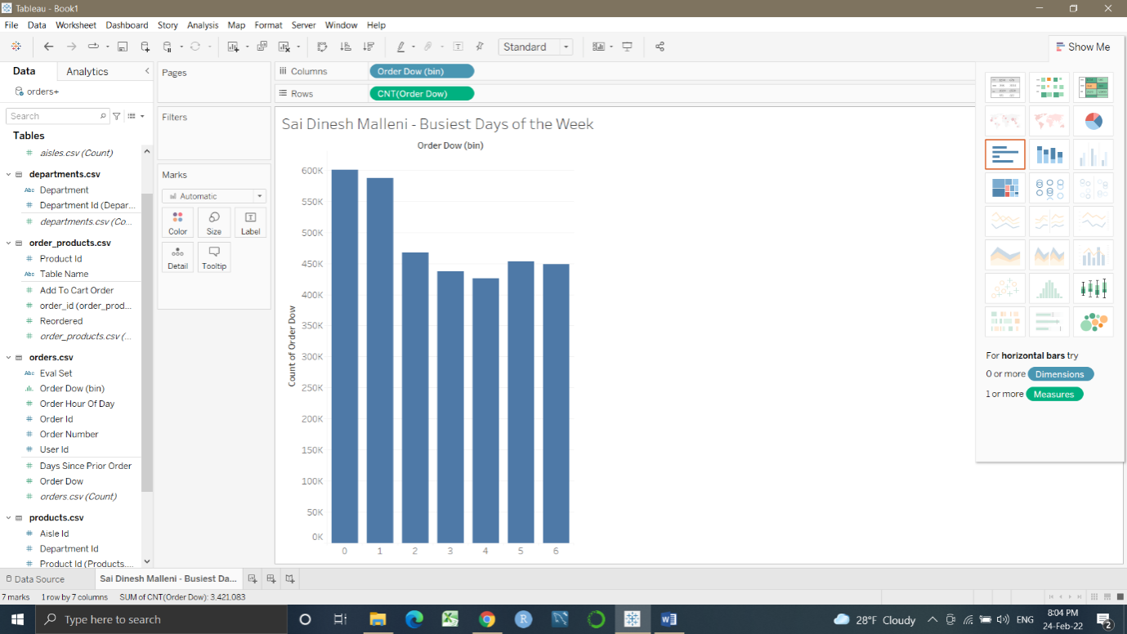
Question 1: Saturday and Sunday

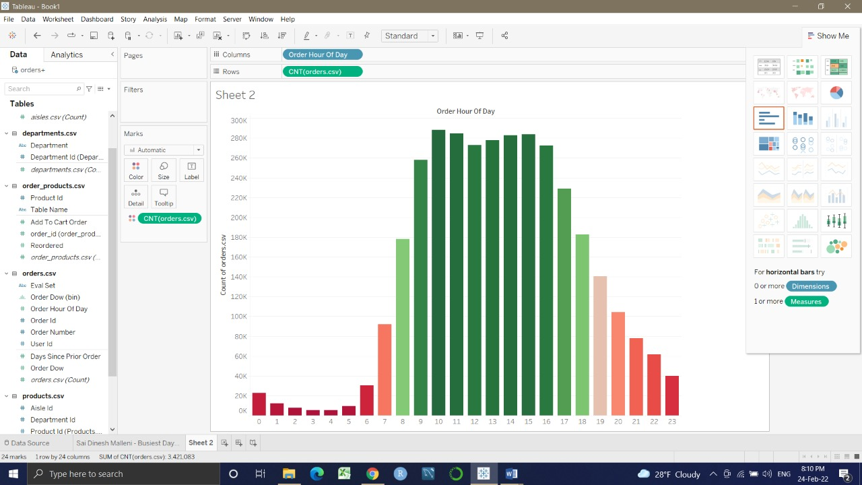
Question 2:
Busiest hours: 0 ,1,2,3,4,5,6,7,8,9,10,11,12,13,14,15,16,17,18,19,20,21,22,23
Top 11 busiest hours: 10,11,15,14,13,16,12,9,17,18,8

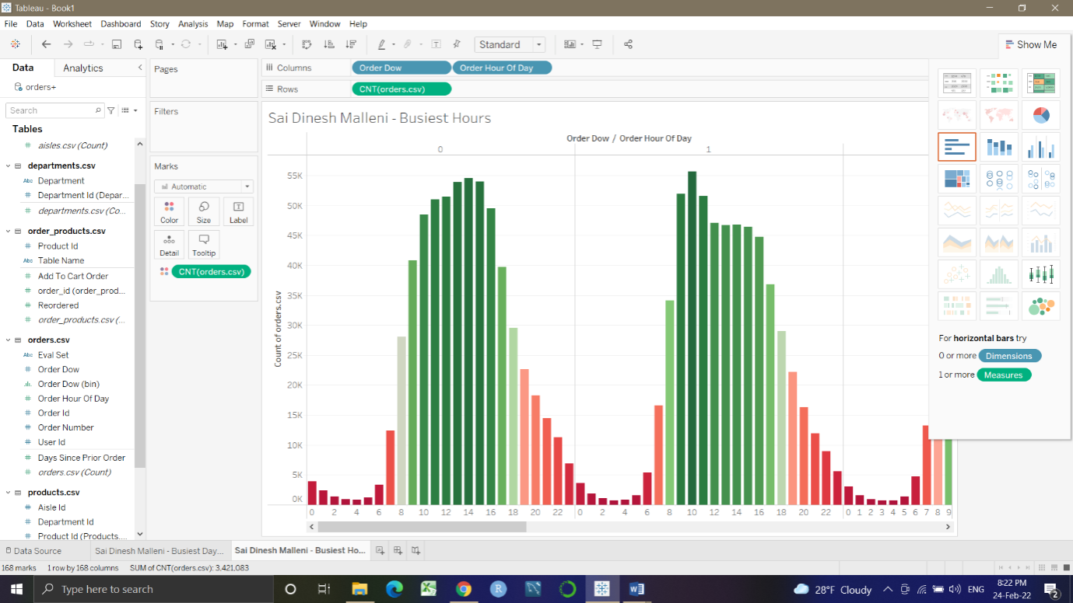

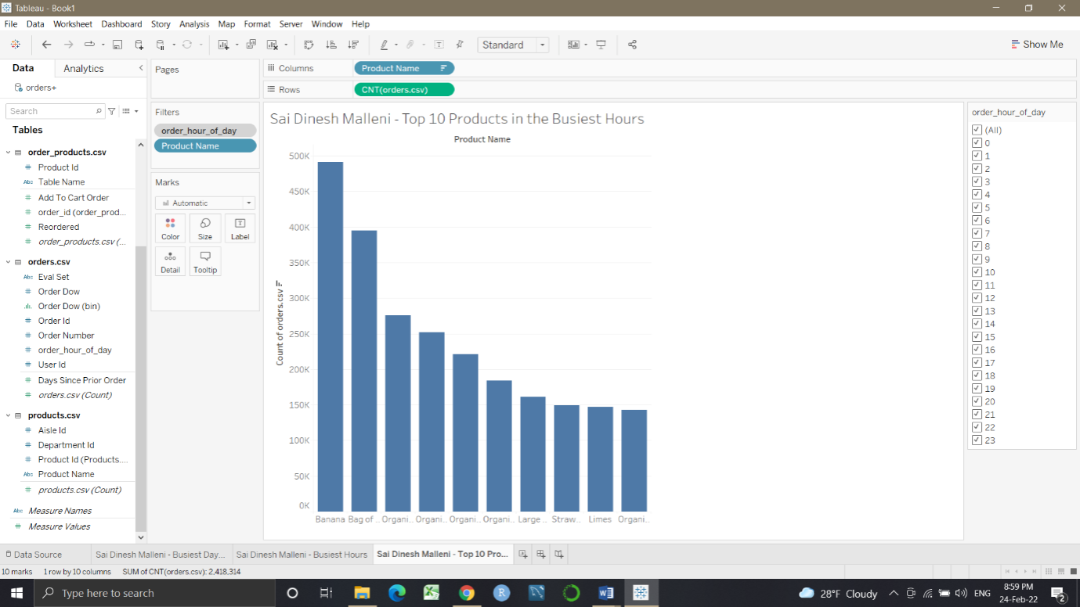

Question 3: Banana

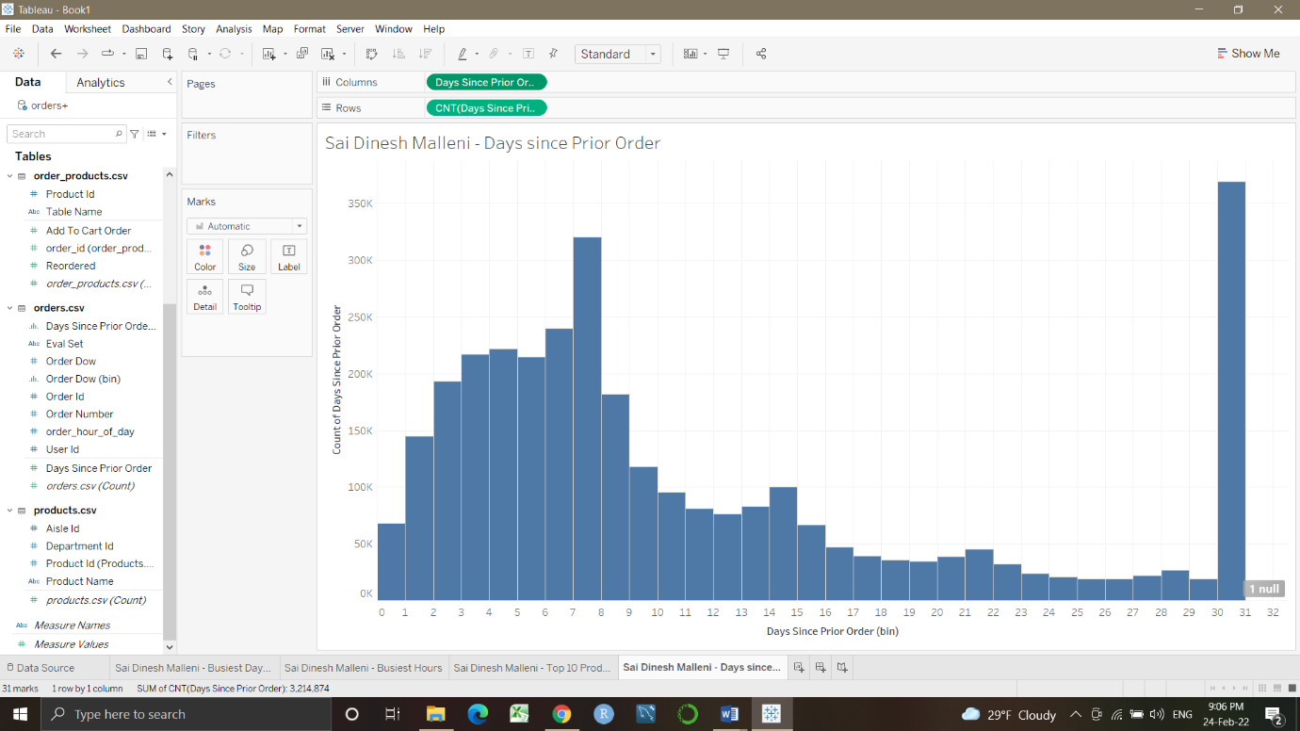

Question 4: Customers are most likely to order again after 30 days

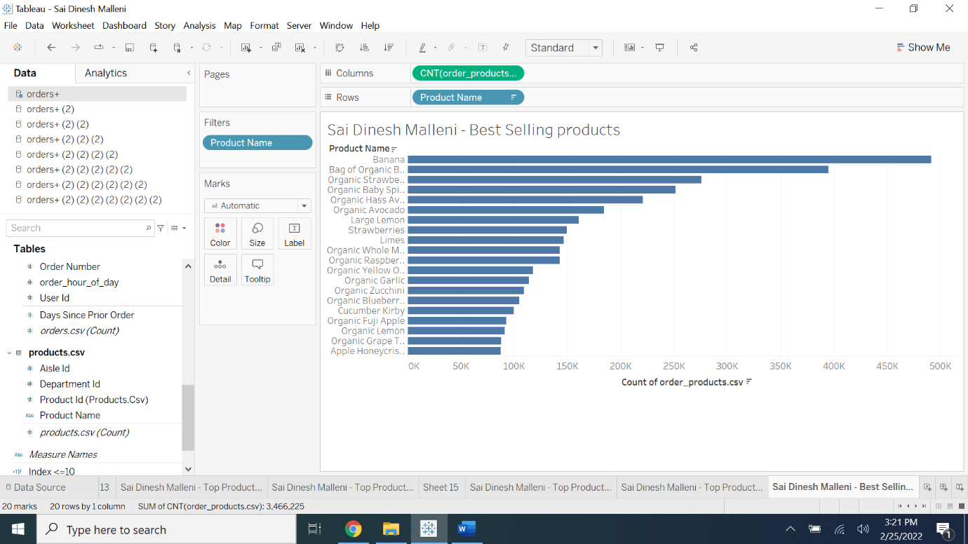

Question 5: Banana, Bag of organic bananas, organic strawberries

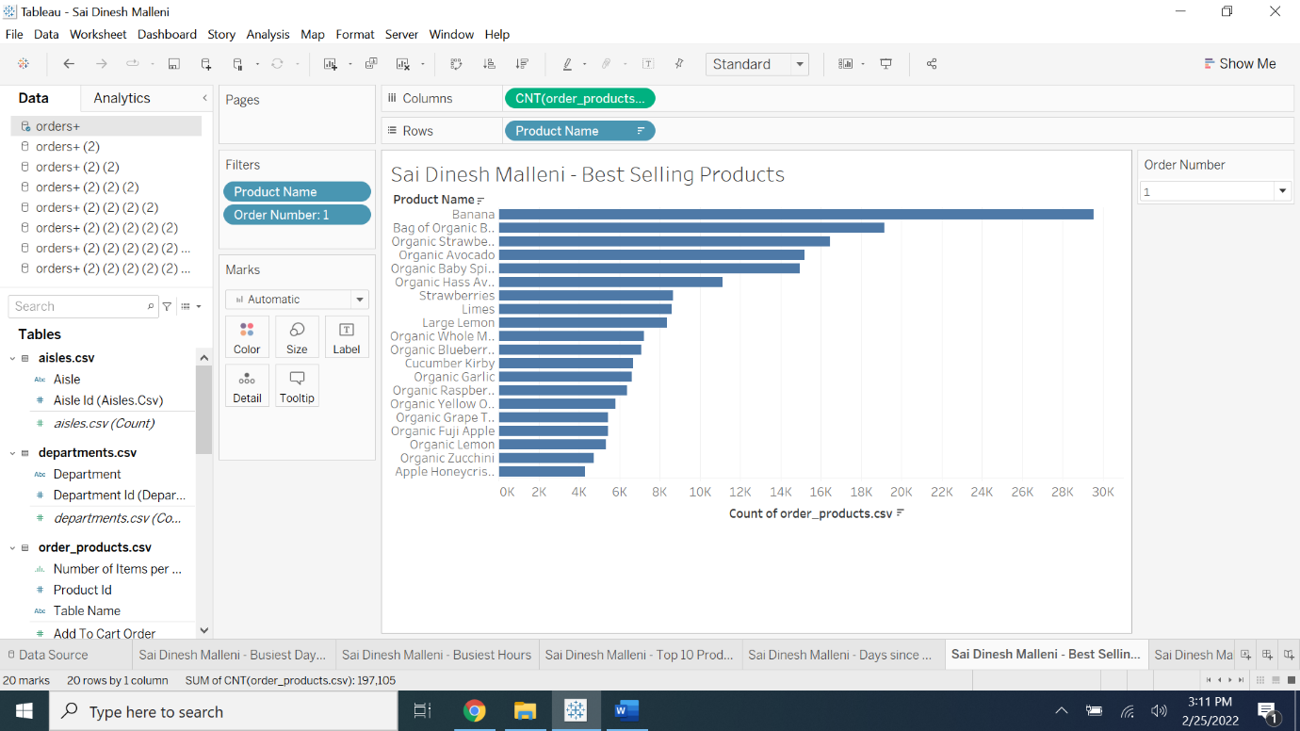

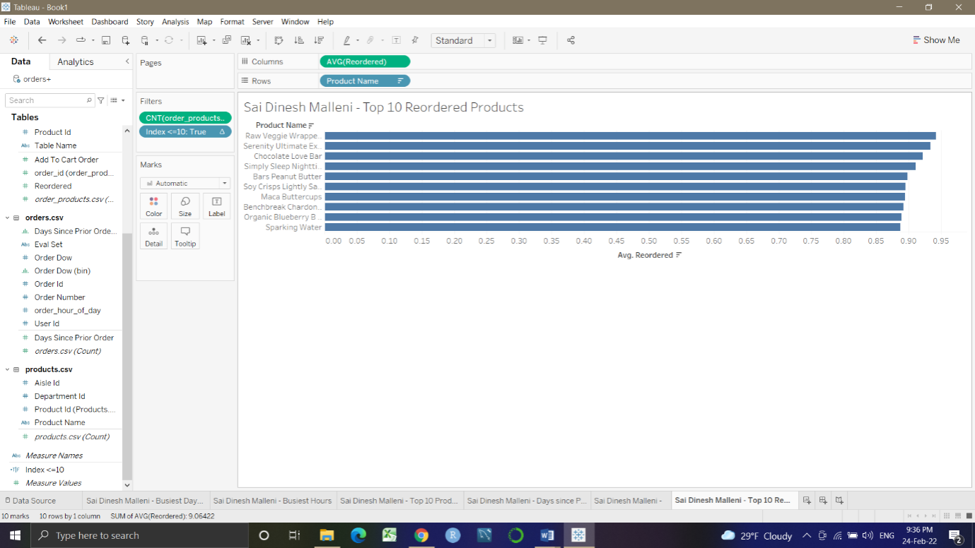

Question 6: Raw Veggie Wrappers 0.94203
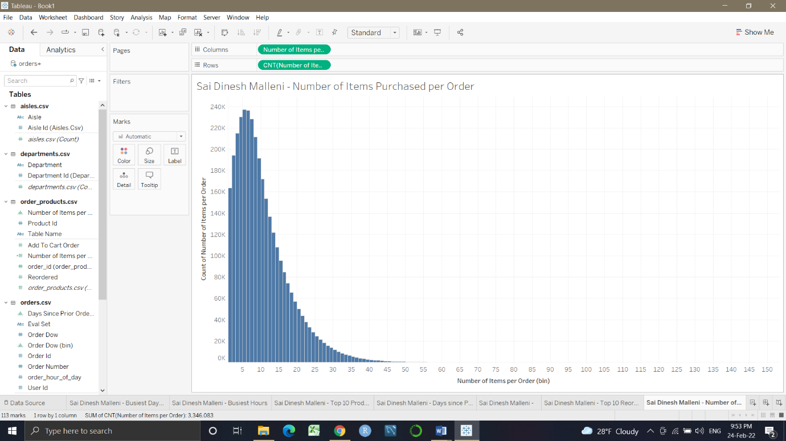

Question 7: 5 items
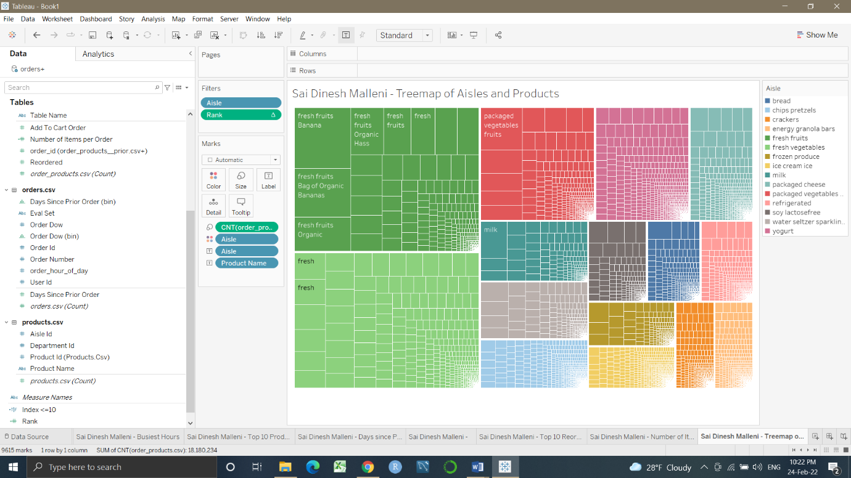

Question 8: fresh fruits, fresh Vegetables, packaged vegetables
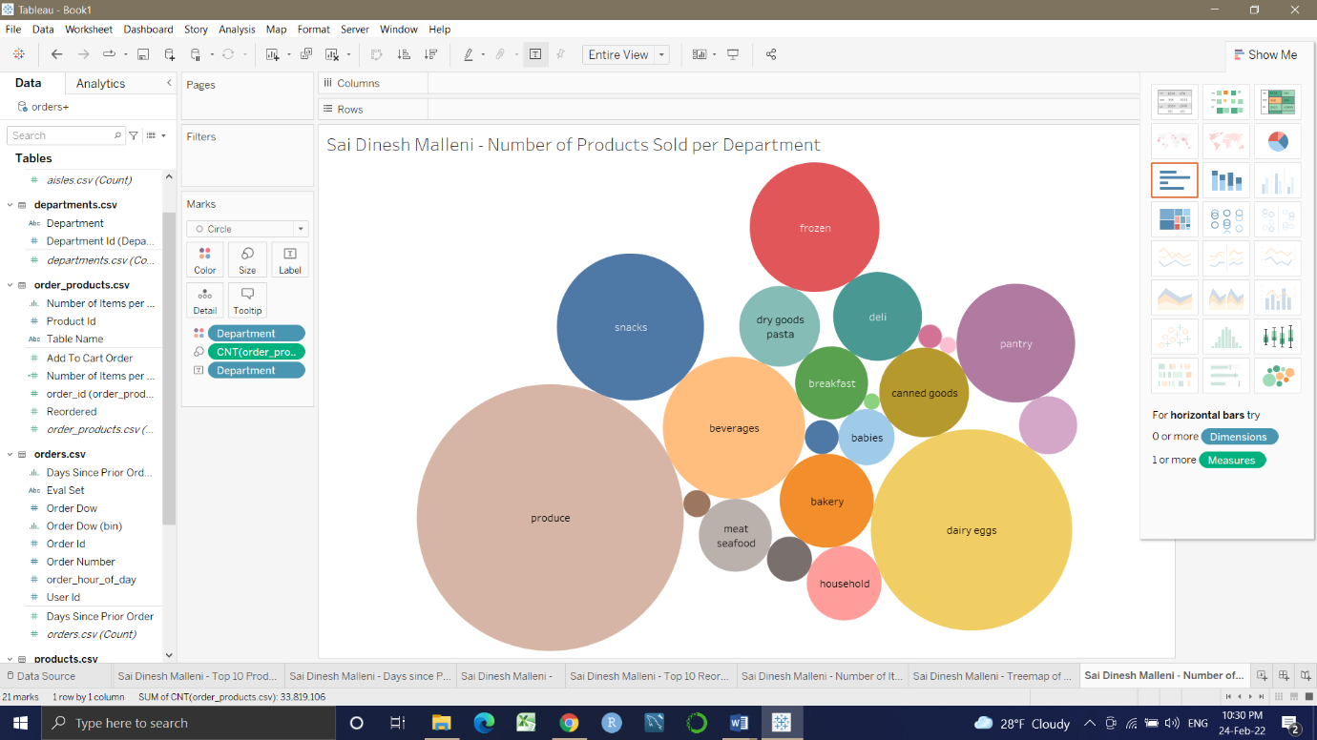

Question 9: produce,dairy eggs
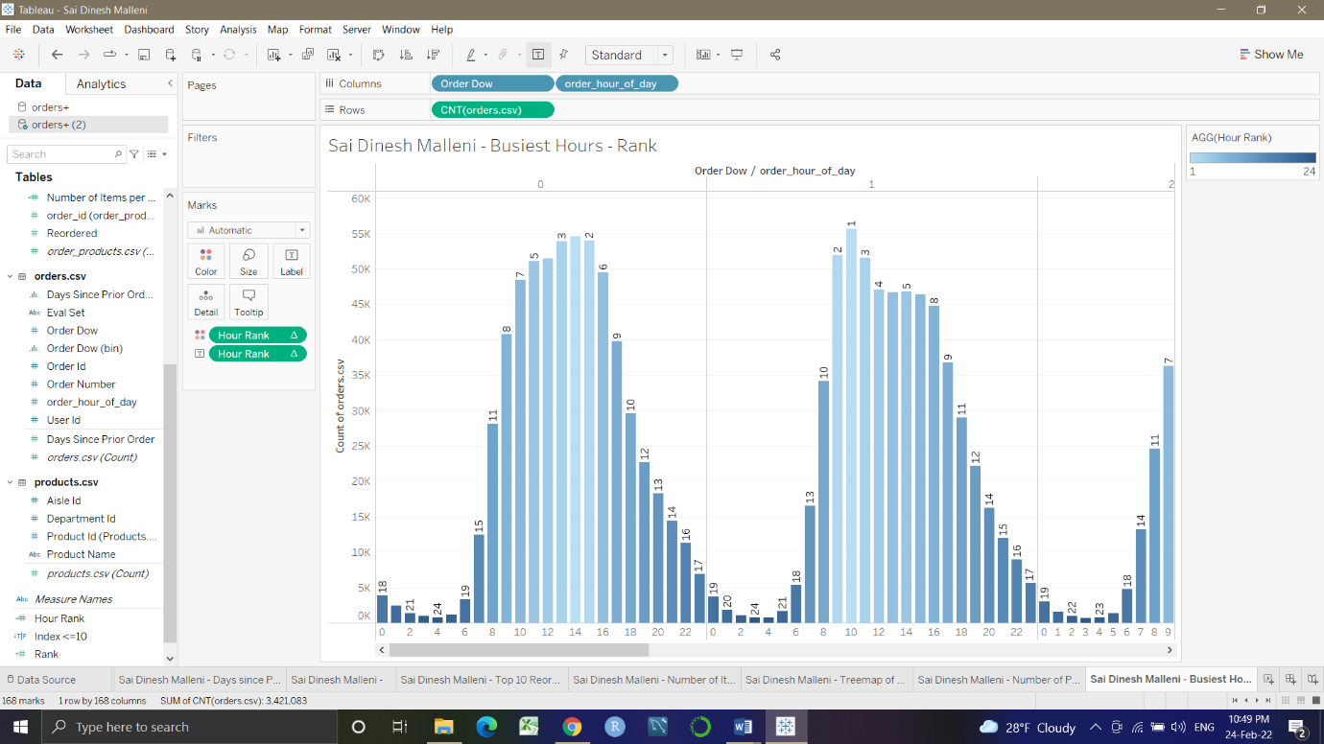

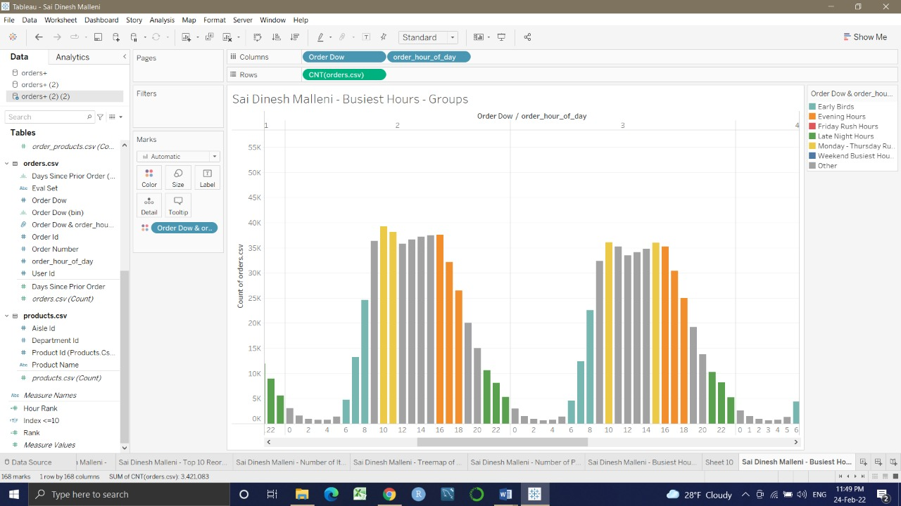

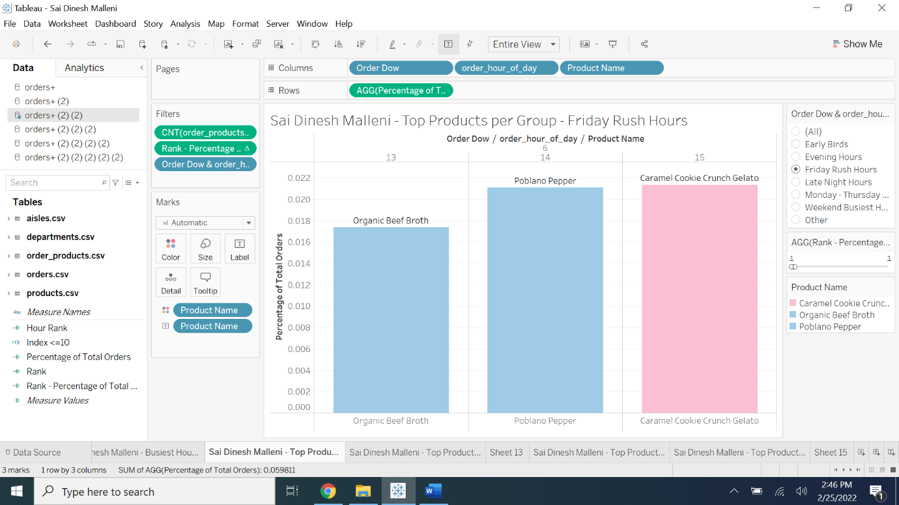

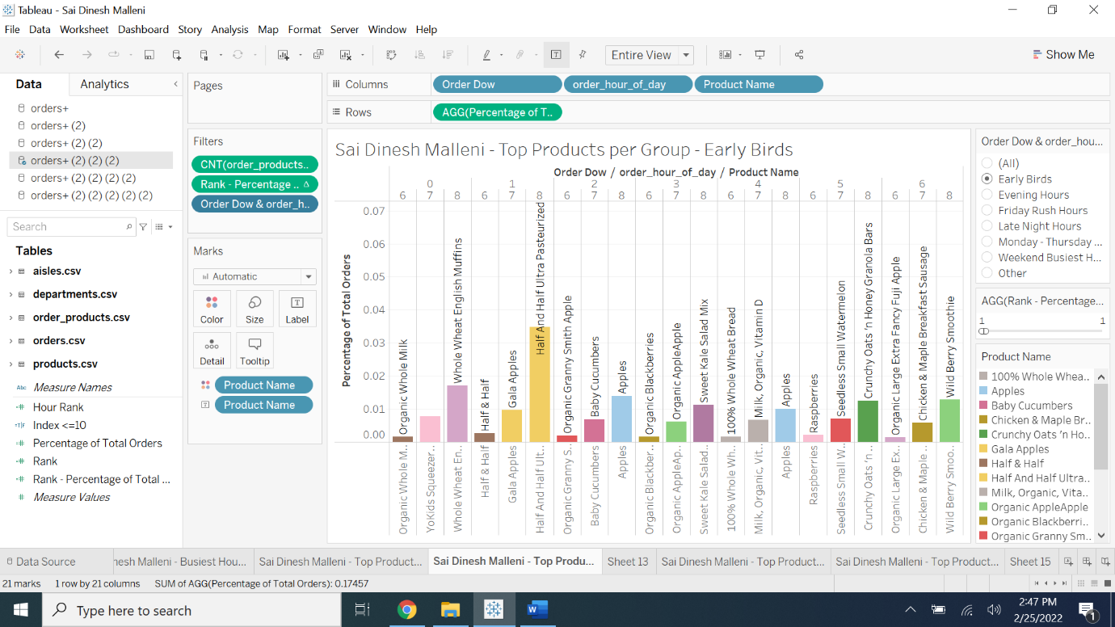

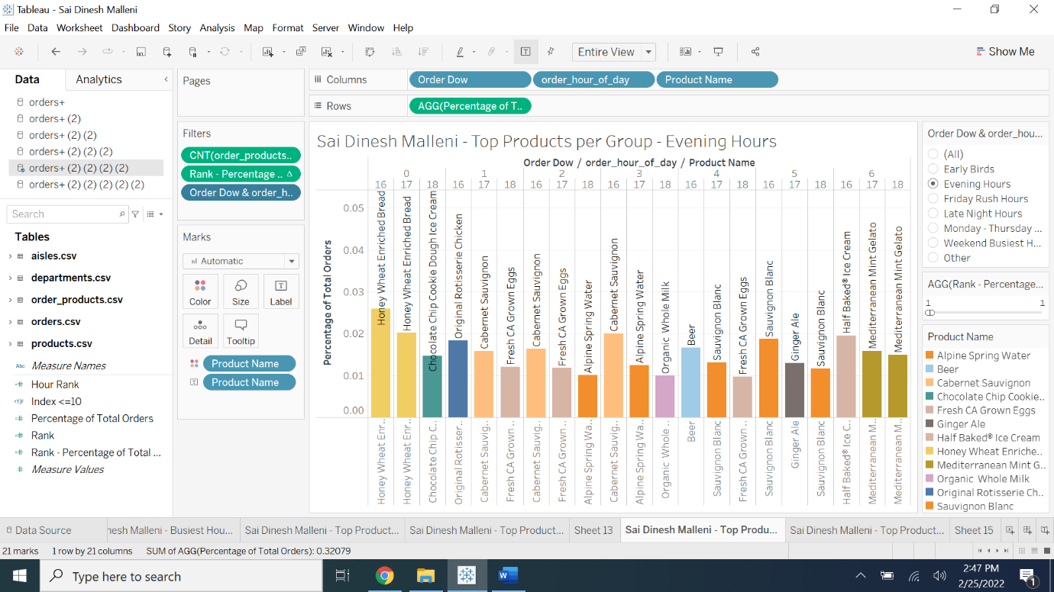

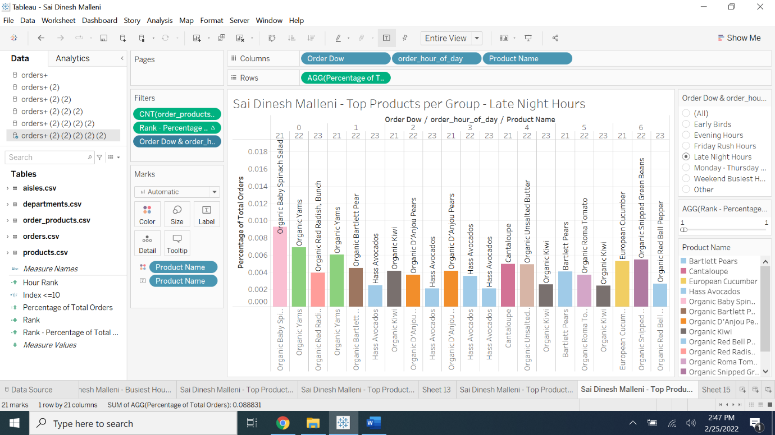

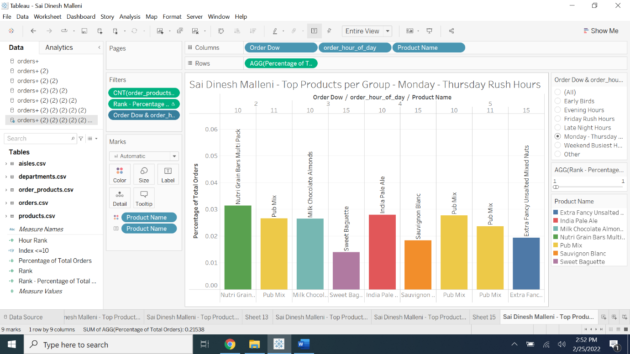

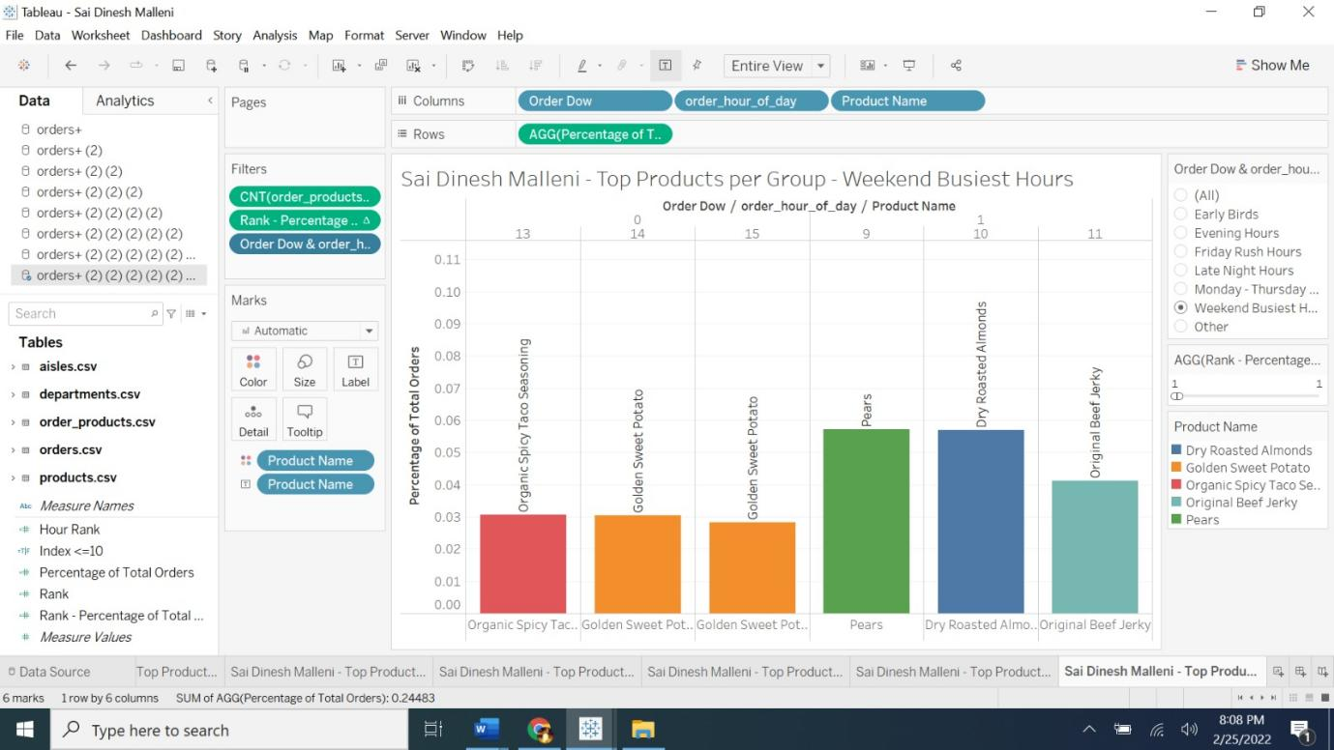

SECTION 5:
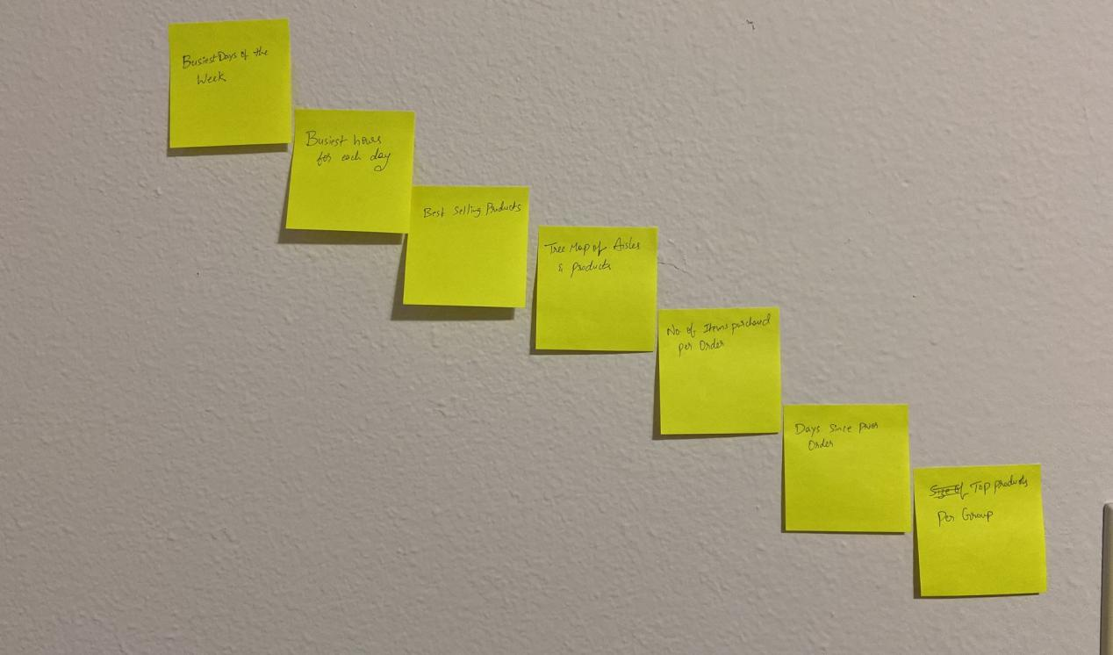

Freytag’s Pyramid:
- Busiest Days of the week - Beginning
- Busiest Hours for each day - Beginning
- Best Selling Products - Rising Action
- Tree Map of Aisles & Products - climax
- No. Of Items purchased per Order - climax
- Days since prior order - Falling Action
- Top products per group - Resolution

SECTION 6:
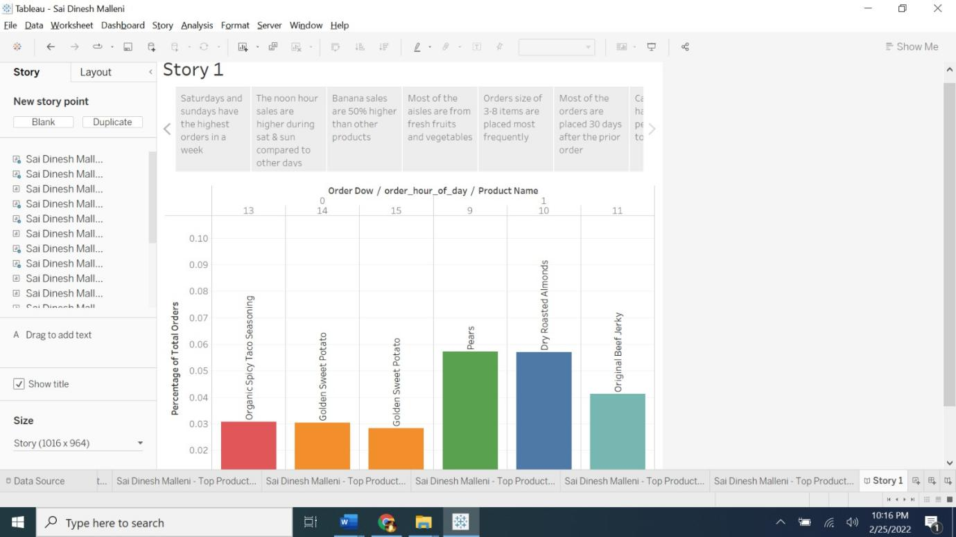

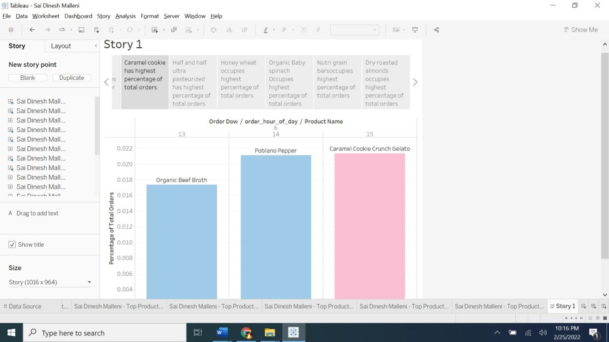

SECTION 7:
